**TABLE OF CONTENTS**

TITLE 2

1. ABSTRACT 2
2. PROBLEMSTATEMENT 3
3. OBJECTIVEANDSCOPE 3
4. PROJECT DESCRIPTION 4
5. METHODOLOGY 5
6. HARDWARE AND SOFTWARESUPPORT 7
7. POSSIBLEOUTCOMES 8
8. REFERENCES 8

# **ABSTRACT**

Now a day’s people in rural areas have to go to the panchayath office in their location to know about the benefits of the panchayath. It requires a lot of time and may result in work delays. The data in the office has to be maintained manually. There is no security for the data and faults can be encountered during entering the data mainly which require higher calculations. People also face so many problems in their area. They complain to their respective ward members but they may or may not respond quickly. There are many other problems in the present-day panchayath raj system. So, this system provides solutions to all the problems in the current system. It provides online services to the people living in that area. All the services which are done manually are made online in the project with automation. The people can know about their panchayath activities, notifications, and all other information related to their villages. All the applications and certificates are applied and verified online. The users in the village can complain about their problems and feedback online. Suggestions are also accepted by the people for the development of their village..

# **PROBLEM STATEMENT**

Implementing a Full-stack E management system that establish a transparent, User-friendly ecosystem to tackle various problems and provides effective service to the development of the rural areas.

# **OBJECTIVE AND SCOPE OF THE PROJECT**

**Objectives:**

* Online tax payment can provide contactless, transparent, and faster delivery of service.
* The people will come to know about the new schemes which are provided by government officials.
* Users can see the development rate at their ward in comparison to other wards.
* The people of the village can easily contact the officials regarding any issues such as availing services, complaints, feedback, and application filling.
* The availability of the officials can be easily tracked.
* Application status can be viewed at the portal.

**Scope:**

* People can request an application, suggestion, and complaint anywhere and at any time without any delay.
* Automation can reduce human error and standardize processes.

# **PROJECT DESCRIPTION**

This project is aimed at developing an E-Gram Panchayath Management System with automation. It is an online-based application that can be accessed through the internet. This System may be used for monitoring gram panchayath activities. The Information about Schemes published by the government or any other activities and billing records will be updated by the officials.

It is a user-friendly website, only the admin has the authority to give access or choose login members. EGPMS (E-Grama Panchayath Management System) is an online-based application that aims to provide information keep Records and Documents such as birth certificates, death certificates, residential certificates. Users can access the data which are required and only body members have the authority to upload the data. It helps the people in that area to easily complete their work which involves the action of the authority of the panchayath people.

Even if the officer is not available in the village, user can verify applications online. People can view the distribution of funds which are collected through taxes. The overall distribution of tender funds which is received from the government is made transparent to the people.

# **METHODOLOGY**

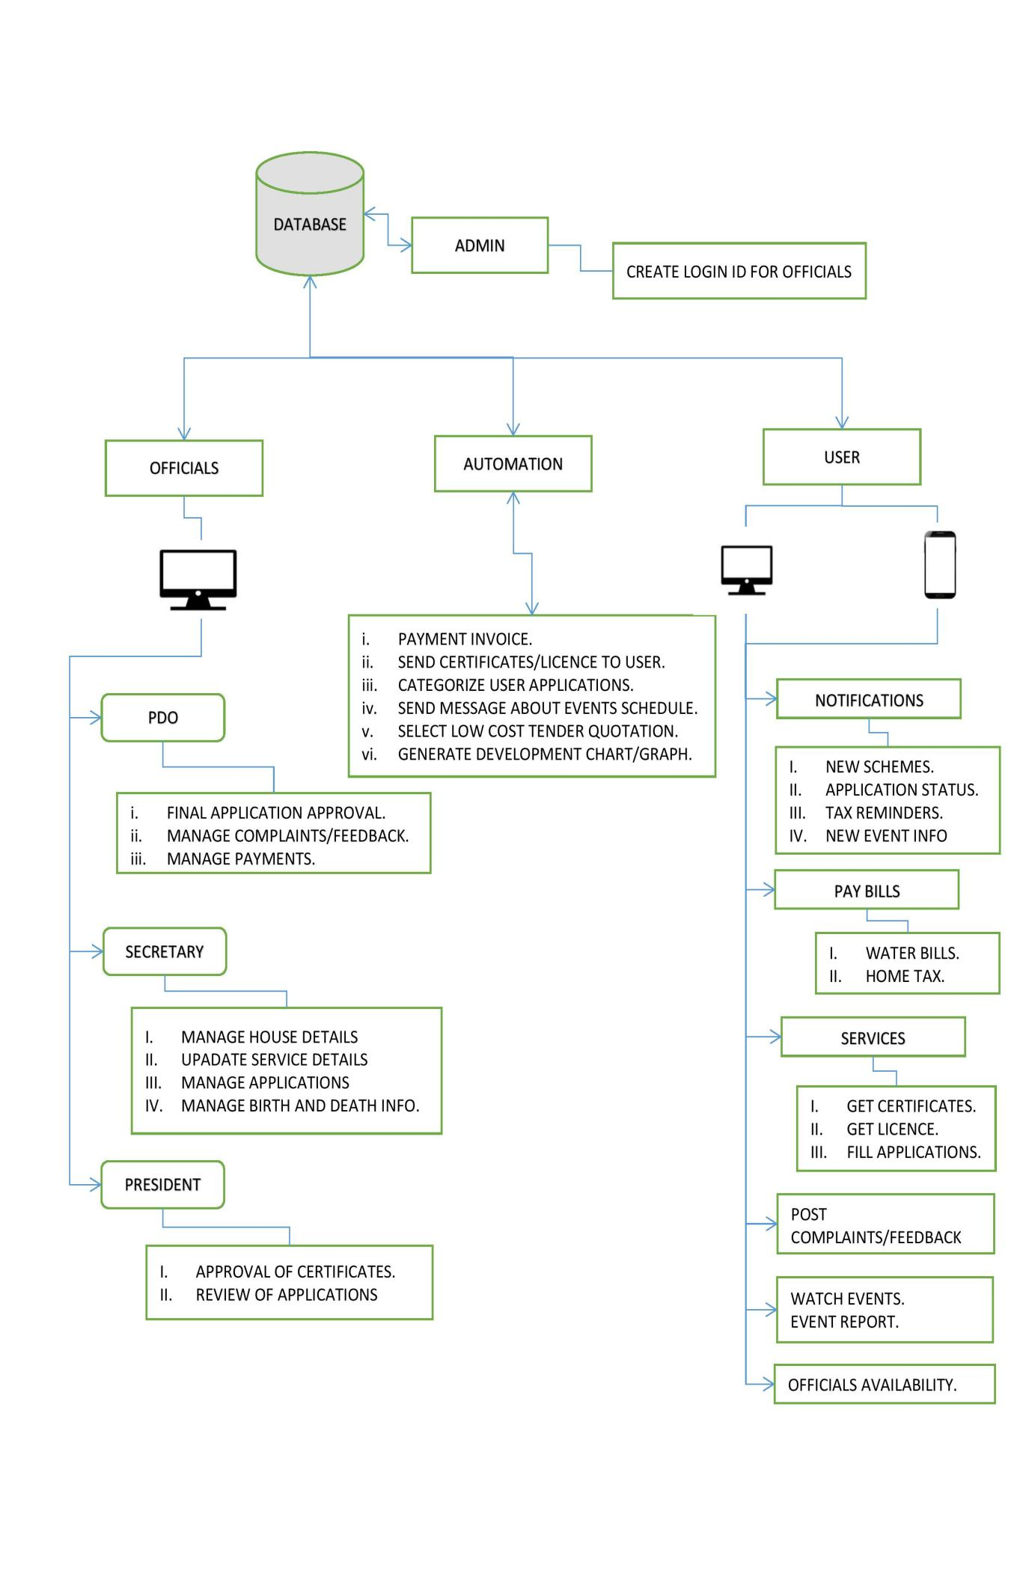

Figure 1: Block Diagram

1. Admin:

* Create login ID for the officials. He monitors all the functionality carried out in the system.

1. Officials:
2. PDO: Final Application Approval is done by PDO. He/She manages the complaints/feedbacks provided by the people and provides the best possible solution.
3. Secretary: Recording the details of birth, death, and resident information of people. Providing Day-to-Day updates of services available in the Grama Panchayath and managing the applications submitted by the consumers.
4. President: Certificates are approved by the President and review all the applications submitted by the people.
5. User:

* Users can view all the schemes which are published through the website by government officials. All the payments are done online. People can get certificates and licenses by directly applying on the application. Users can also view the status of the application. Users can write Feedbacks or Complaints on the application and check the availability status of the officials.

1. Automation:

Automation can be applied for:

1. Sending an invoice to the consumer after successful completion of the payment.
2. Categorizing all the user applications.
3. Scheduling the events.
4. Generating the Overall Development Chart of Grama Panchayath.
5. Finding the Low-Cost Tender Quotation.

# **HARDWARE AND SOFTWARESUPPORT**

**Software Requirement**:

* Frontend development:

Basics: HTML, CSS, JavaScript

Framework: Reactjs, React-Native

* Backend development:

Nodejs: It is an opensource cross platform backend JavaScript runtime environment that runs on V8 engine and executes JavaScript code.

* Database:

MongoDB: is a document oriented NoSQL database program. it uses JSON-like document.

* Version Control:

Git

* Package manager:

npm

* Tools:

Visual studio code, Android studio, UiPath Studio, UiPath orchestrator

**Hardware requirement:**

* Intel core i3 or any higher end processor
* 4GM RAM

# **POSSIBLEOUTCOMES**

* Improving delivery of services to citizens.
* Transparency, Accountability, Efficiency and RTI compliance ofPanchayath.
* Consumers will get the information about the new schemes easily.
* Tax payment procedure will be optimized.
* Consumers can watch the events that are happening in the Grama panchayath through a live stream.
* There may be a possibility of a decrease in the Corruption rate due to the transparency in the system.
* Automation will reduce the work load of the officials.

# **REFERENCES**

[1] Ch. Leela Poornima, Ch. Pavani, G. Parameswari, K. Subhash Reddy, “Automation of Gram Panchayat”,

International Journal of Emerging Trends in Engineering Research, 2016.

[2] <https://panchatantra.kar.nic.in/panchamitra/>

[3] https://rdpr.karnataka.gov.in./english